Project Report

# **1 INTRODUCTION**:

* 1. Overview:

This report delves into the fascinating realm of business expenses and provides a visual exploration of the various expenditures incurred by different businesses. It showcases the distribution of expenses, identifies key cost drivers, and highlights areas of potential optimization or concern. The visual representations allow for intuitive analysis, facilitating a deeper understanding of expenditure patterns and their implications for business performance. Decision-makers, financial analysts, and stakeholders can gain valuable insights into the financial health of businesses, identify areas of inefficiency or opportunity, and make informed decisions to optimize resources and drive growth. To Extract the Insights from the data and put the data in the form of visualizations, Dashboards and Story we employed Tableau tool.

## Purpose:

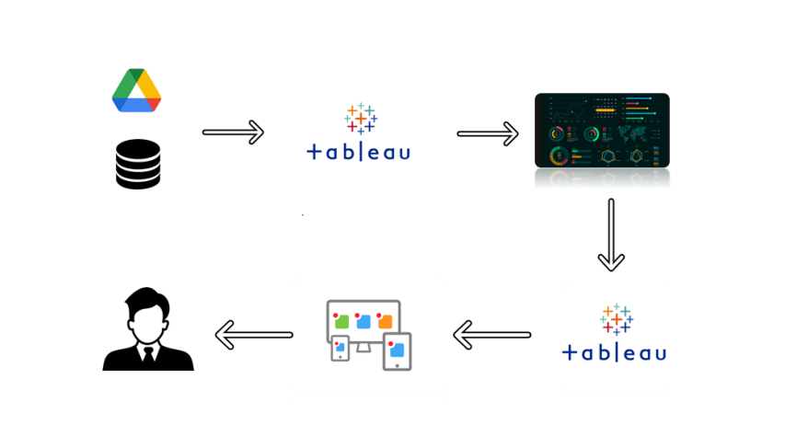

# **Problem Definition & Design Thinking:**

2.1 Empathy Map:

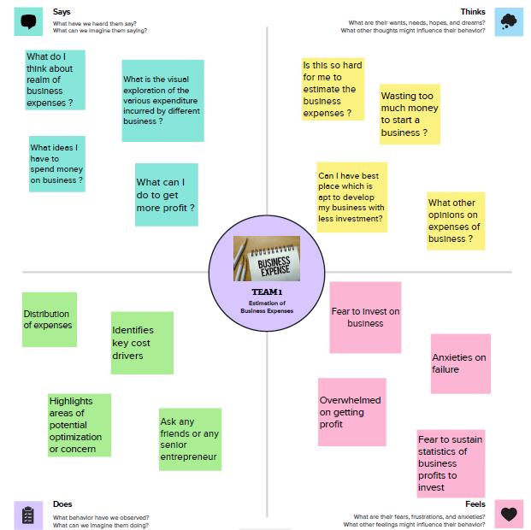

2.2 Ideation & Brainstorming Map:

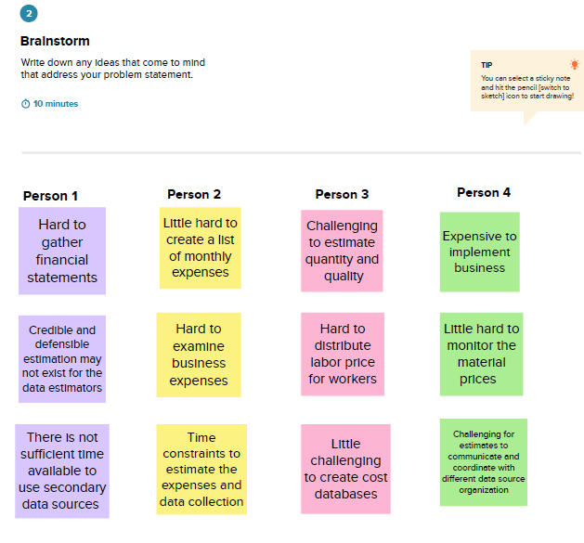

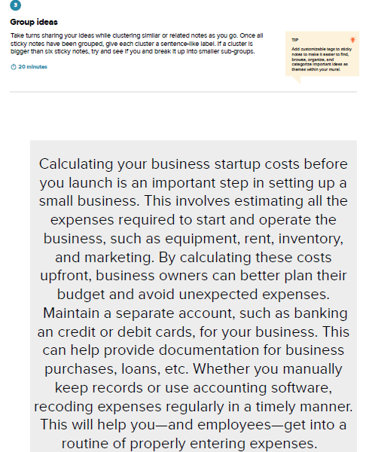 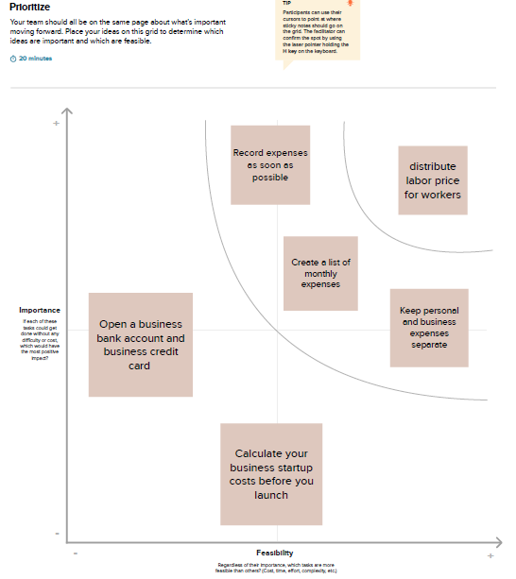

1. **RESULT:**

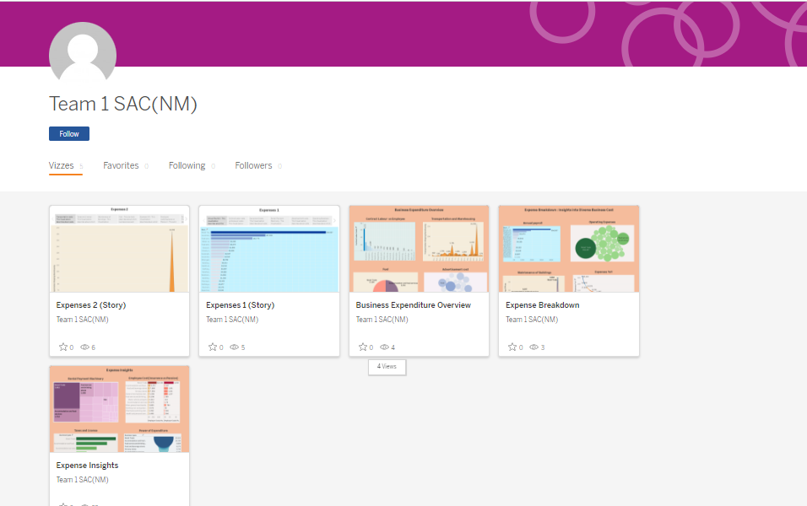

1. **ADVANTAGES & DISADVANTAGES:**

There are many positive reasons a business or organization might choose to leverage cost-benefit analysis as a part of their decision-making process. There are also several potential disadvantages and limitations that should be considered before relying entirely on a cost-benefit analysis.

4.1 Advantages of the proposed solution:

A Data-Driven Approach

Cost-benefit analysis allows an individual or organization to evaluate a decision or potential project free of biases. As such, it offers an agnostic and evidence-based evaluation of your options, which can help your business become more data-driven and logical.

Makes Decisions Simpler

Business decisions are often complex by nature. By reducing a decision to costs versus benefits, the cost-benefit analysis can make this dilemma less complex.

Uncovers Hidden Costs and Benefits

Cost-benefit analysis forces you to outline every potential cost and benefit associated with a project, which can uncover less-than-obvious factors like indirect or intangible costs.

4.2 Disadvantages of the proposed solution:

Difficult to Predict All Variables

While cost-benefit analysis can help you outline the projected costs and benefits associated with a business decision, it’s challenging to predict all the factors that may impact the outcome. Changes in market demand, material costs, and the global business environment are unpredictable—especially in the long term.

Incorrect Data Can Skew Results

If you’re relying on incomplete or inaccurate data to finish your cost-benefit analysis, the results of the analysis will follow suit.

Better Suited to Short- and Mid-Length Projects

For projects or business decisions that involve longer timeframes, cost-benefit analysis has a greater potential of missing the mark for several reasons. For one, it’s typically more difficult to make accurate predictions the further into the future you go. It’s also possible that long-term forecasts won’t accurately account for variables such as inflation, which can impact the overall accuracy of the analysis.

Removes the Human Element

While a desire to make a profit drives most companies, there are other, non-monetary reasons an organization might decide to pursue a project or decision. In these cases, it can be difficult to reconcile moral or “human” perspectives with the business case.

1. **APPLICATIONS:**

1. Top-Down Estimate

Once more detail is learned on the scope of the project, this technique is usually followed where high-level chunks at the feature or design level are estimated and are decomposed progressively into smaller chunks or work-packets as information is detailed.

2. Bottom-Up Estimate

This technique is used when the requirements are known at a discrete level where the smaller workpieces are then aggregated to estimate the entire project. This is usually used when the information is only known in smaller pieces.

3.Analogous Estimating:

This project estimation technique is used when there is a reference to a similar project executed and it is easy to correlate with other projects. Expert judgment and historical information of similar activities in a referenced project are gathered to arrive at an estimate of the project.

4. Parametric Estimate

This technique uses independent measurable variables from the project work.  For example, the cost for construction of a building is calculated based on the smallest variable as the cost to build a square feet area, the effort required to build a work packet is calculated from the variable as lines of codes in a software development project. This technique gives more accuracy in project estimation.

5. Three-point Estimating

This technique uses a mathematical approach as the weighted average of an optimistic, most likely and pessimistic estimate of the work package.

**6 CONCLUSION:**

Cost drivers were a significant focus in the literature survey, with researchers extensively investigating the factors influencing business expenses. Studies highlighted labor costs, material costs, overhead expenses, and marketing expenditures as key drivers. Accurately identifying and tracking these drivers was emphasized as essential for effective expense management and control.

**7 FUTURE SCOPE:**

* AI, Machine Learning and Big Data implementation will play a huge role in providing quality services and ensuring business progress.
* Data quality management is poised to become a crucial digital trend.
* As consumers become more conscious of privacy and receptive to personalized services, business analytics will pave the way for better and secure customer experience.
* Predictive and prescriptive analytical approaches will force companies to rethink traditional models favoring unconventional technologies that increase sustainability and chances of success.
* Business analytics is expected to significantly impact marketing, sales, customer experience, finance, risk management, HR, and social media practices, among others.
* Business professionals with an in-depth understanding of business analytics are better positioned to be industry leaders. They will have an edge in addressing short-term challenges and fulfilling long-term goals by constantly updating their descriptive and predictive analytical models to eliminate uncertainties and tap into new business opportunities.

**8 APPENDIX:**

References:

1. <https://public.tableau.com/app/profile/abirami.siva.nm./vizzes>
2. <https://drive.google.com/drive/folders/1CCxjo561-uTwp260h-YbAj9jurbEcXcB?usp=drive_link>